# How Much Does it Cost to Outsource Video Editing

Video content has become a powerful tool for businesses to reach their target audience and communicate their message effectively.

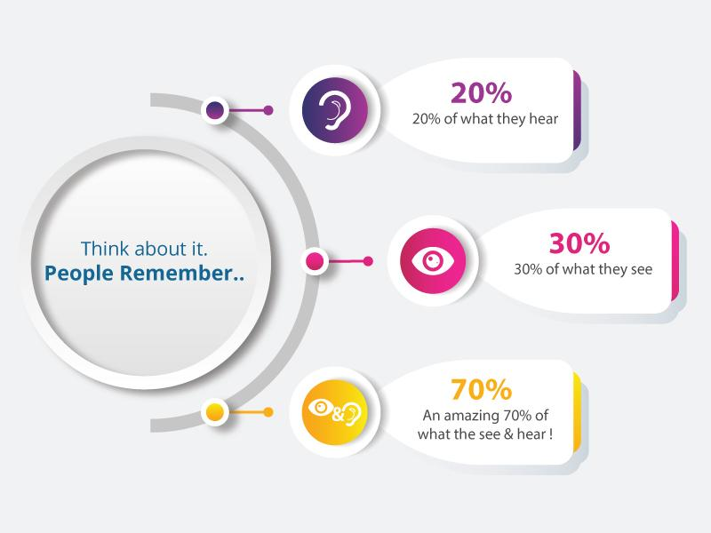

[Source](https://www.videocaddy.com/blog/wp-content/uploads/2019/11/work-2.jpg)

However, creating high-quality videos that engage and captivate the audience is no easy feat. It requires expertise, time, and specialized equipment that not all companies have. This is where outsourcing video editing comes in.

This article will delve deeper into these pain points and explore how outsourcing video editing can help your company overcome them and produce high-quality videos that meet your needs.

## What is Video Editing?

Video editing is manipulating and rearranging video footage to create a new work. It involves selecting and arranging individual raw footage, stock video, and sound recordings to form a cohesive final product that tells a story or communicates a message.

A well-edited video can significantly impact potential customers, while a poorly edited video can be ineffective and even detrimental to the message being communicated. Therefore, having the necessary skills and expertise to edit videos effectively or to outsource video editing to professionals or third-party services who can deliver high-quality results is essential.

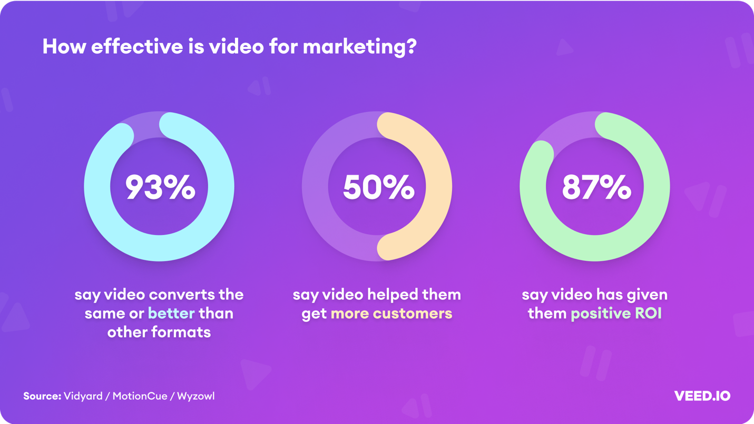

[Source](https://assets-global.website-files.com/616e938268c8f0a92cb2b540/62f42c73d6ee1e57d20e6650_Effectiveness%20of%20Video%20Marketing.png)

## Why Should You Outsource Video Editing Services?

Editing videos can be time-consuming and detract from the other responsibilities you must focus on.

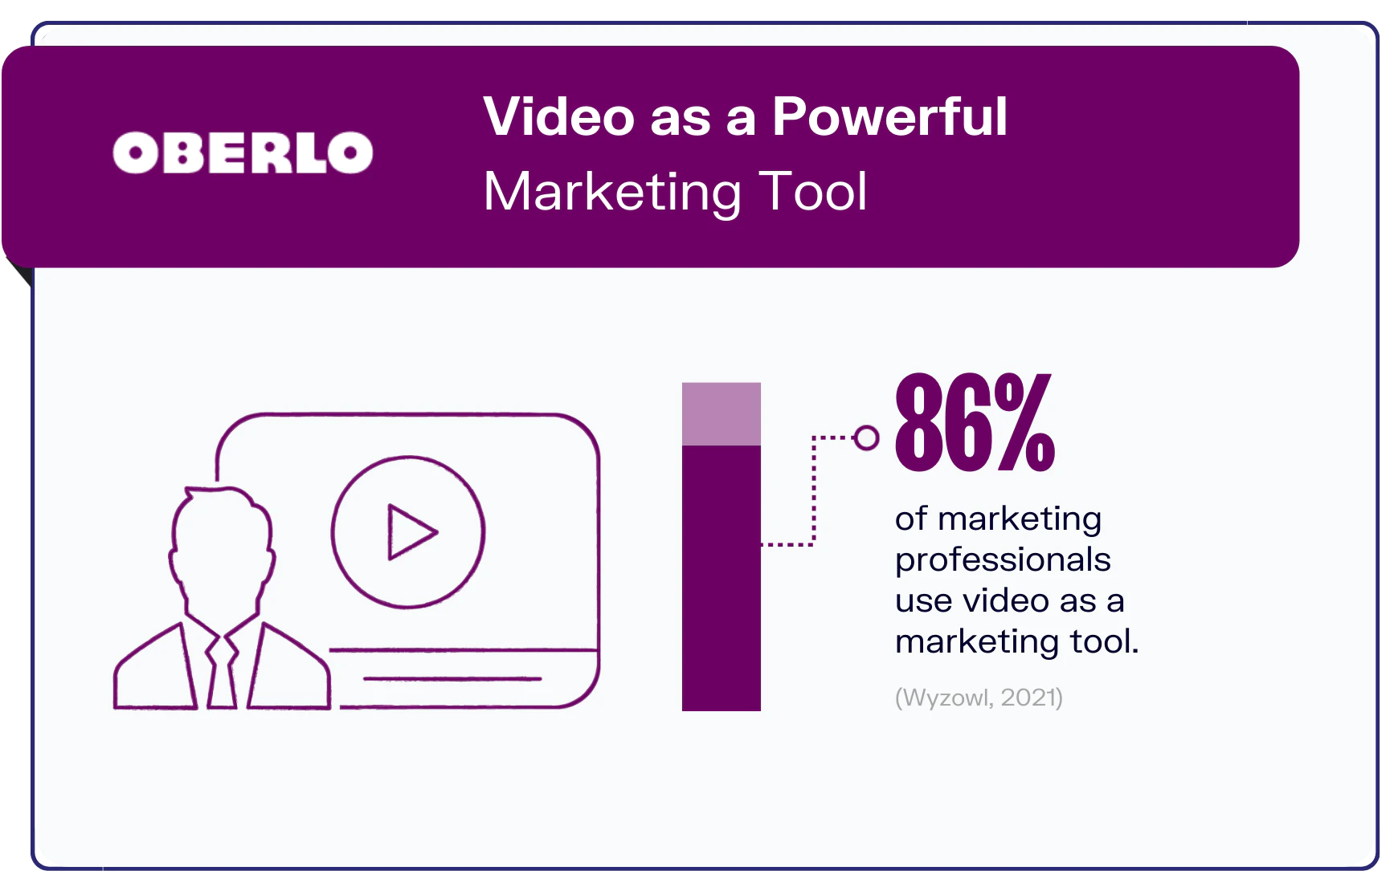

[Source](https://www.oberlo.com/media/1676281016-video-marketing-statistics-graphic3.png?fm=webp&w=1824&fit=max)

Below are the benefits that you can get by outsourcing video editing services:

### Access to Specialized Expertise

Professional video editors or video production company has the necessary skills and expertise to edit videos effectively. They have experience with various editing techniques and software and can produce high-quality videos that meet the company's specific needs.

### Time Savings

Video editing is a time-consuming process that requires attention to detail and a significant amount of effort. Outsourcing video editing allows companies to free up their internal resources and focus on other aspects of their business while professionals take care of video editing.

### Cost Savings

Outsourcing video editing can be more cost-effective than hiring an in-house editing team. Companies only need to pay for the specific amount of video editing they require without worrying about the costs of hiring and training an in-house team.

### Access to Specialized Equipment

Video editing requires specialized equipment and video editing software, such as Adobe Premiere, Final Cut Pro, CyberDirector, etc., which can be expensive to purchase and maintain. Outsourcing video editing allows companies to access the necessary equipment without investing in it themselves.

### Flexibility

Outsourcing video editing allows companies to be more flexible with their video production. They can choose to outsource video editing on a project-by-project basis, which gives them the flexibility to scale up or down depending on their needs.

### Highest Quality Results

Professional video editors have the skills and expertise to produce high-quality videos that engage and captivate the audience. Outsourcing video editing ensures that the final product meets the company's needs and delivers the desired message effectively.

## Factors Affecting the Cost of Video Editing

Outsourcing video editing is a great way to save time and produce high-quality content. It allows you to focus on other aspects of your business while ensuring that your videos are polished and engaging. But how much does it cost to outsource video editing?

### The Complexity of the Project

The more complex the project, the more expensive it will be. A simple video that needs a few basic edits will cost less than one that requires advanced effects and animation. Some projects may require thorough video edit, such as color grading, video enhancements, etc., which adds to the video editing costs.

The project's complexity also covers what video project you want to produce. It can be corporate videos, animated videos, and even promotional videos such as TV ads.

### Video Length

Longer videos like documentation, movie, or wedding coverage will generally cost more to edit as they require so many things, such as compiling all the clips. Sometimes they need same-day edits than those shorter videos such as commercials.

### The Quality of the Source Footage

Suppose the source footage (raw footage) is of poor quality. In that case, producing a high-quality video will require more editing, like color correction or even a few video enhancements. This will increase the cost of the project.

### The Level of Experience of the Video Editor

Experienced editors will typically charge more than less experienced editors. Sometimes, freelance video editors may charge you an hourly rate.

### Contract Length

The contract length can greatly influence video editing rates. Some professional video editors work on longer contracts and can offer you discounts, while some who offers shorter contract may charge you higher costs.

### Location

If the video editing company/freelance editors you want to hire are based in major cities with higher living costs, they will generally charge you more than those in cities with lower living costs.

## Average Cost to Outsource Video Editing

Just like graphic designing, there's nothing much difference whether you'll come from small, medium-sized, or large companies. The video editing prices only vary depending on the type of video services you will avail.

Below are some video editing services together with their corresponding average costs:

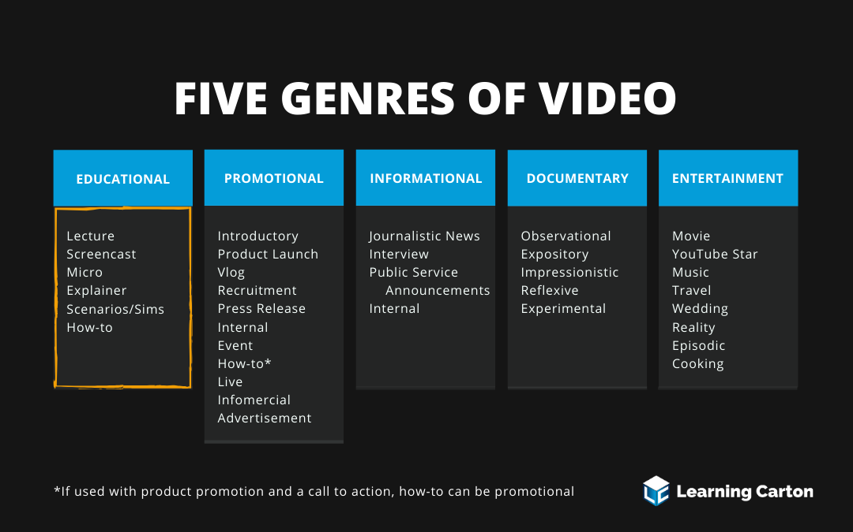

[Source](https://learningcarton.com/wp-content/uploads/2020/03/5genresOfVideo2.png)

* **Weddings and Events:** Editors crave beautifully edited video footage of all milestone events. The starting pay rate for wedding and event professional videographers is around $20/hour but can go up to [$200/hour or more](https://www.videopixie.com/wedding-video-post-production) depending on the editor's experience and abilities or sometimes when clients request post-production content.
* **Commercials and branded storytelling:** This video type requires creative work and humor according to your branding. According to the [Blue Collar Post Collective](https://www.bluecollarpostcollective.com/surveys-studies/) (BCPDocumentaries'own of pay rates for freelance commercial and branded storytelling editors is as follows:
  + Hourly rate: [$20–$500](https://docs.google.com/spreadsheets/d/170pUPO-XNLuAjrtCD3QzXEVnBRbTEYYN40gKc-JyGC8/edit#gid=52472486); average rate per hour: [$83](https://docs.google.com/spreadsheets/d/170pUPO-XNLuAjrtCD3QzXEVnBRbTEYYN40gKc-JyGC8/edit#gid=52472486)
  + Day rate: [$175–$2,000](https://docs.google.com/spreadsheets/d/170pUPO-XNLuAjrtCD3QzXEVnBRbTEYYN40gKc-JyGC8/edit#gid=52472486); average day rate: [$771](https://docs.google.com/spreadsheets/d/170pUPO-XNLuAjrtCD3QzXEVnBRbTEYYN40gKc-JyGC8/edit#gid=52472486)
* **Documentaries:** Documentaries' pay rates vary significantly. Some editors may work at a much lower pace for documentaries they see as passion projects or focusing on precious topics, and they want to produce a compelling story. The [BCPC](https://www.bluecollarpostcollective.com/surveys-studies/) shows documentary video editing rates as follows:
  + Hourly rate: $55–$150; average rate per hour: $87
  + Day rate: $325–$1,500; average day rate: $692
  + Weekly rate: $500–$5,000; average weekly rate: $3,597
* **Episodic programs:** Rates for TV show editing are more standardized due to union regulations. General rates according to the BCPC are:
  + Hourly rate: $42–$150; average rate per hour: $89
  + Day rate: $475–$1,100; average day rate: $763
  + Weekly rate: $2,000–$7,000; average weekly rate: $4,250
* **Scripted features:** Editors working on scripted features will likely be part of the [Motion Pictures Editors Guild](https://www.editorsguild.com/Wages-and-Contracts), which regulates contracts and rates. According to ZipRecruiter, as of December 2022, the average annual pay for a film video editor in the United States is [$54,055](https://www.ziprecruiter.com/Salaries/Film-Video-Editor-Salary#:~:text=How%20much%20does%20a%20Film,%2Fweek%20or%20%244%2C504%2Fmonth.) yearly. As per the BCPC, editing rates for scripted features are:
  + Hourly rate: $32–$75; average rate per hour: $52
  + Day rate: $600–$3,000; average day rate: $1,160
  + Weekly rate: $900–$20,000; average rate: $4,728

## Outsourcing Video Editing vs. In-House Video Editing Team - Direct Comparison

Let's break down your options here. First, doing in-house is the do-it-yourself option wherein you will buy all the equipment, hire a professional video editor, or assign team members from your marketing team to be the video production team.

On the other hand, in outsourcing, you hire freelancers or, more commonly, a video production agency to manage video projects for you.

### Initial Setup Cost

* **Outsourcing Video Editing:**

The initial setup costs for outsourcing video editing are generally lower than setting up an in-house team, as outsourcing doesn't require investment in hardware, software, and infrastructure. The cost is usually limited to the fees paid to the outsourcing company, which can range from $50 to $200 per hour, depending on the complexity and scope of the project.

* **In-House Video Editing Team:**

Setting up an in-house video editing team requires significant investment in hardware, software, and infrastructure. The initial cost can range from [$30,000 to $100,000](https://panopto.com/blog/the-real-cost-of-in-house-video-production/), depending on the quality of the equipment, software, and workspace.

### Ongoing Expenses

* **Outsourcing Video Editing:**

The outgoing expenses for outsourcing video editing can vary depending on the complexity and scope of the project. However, outsourcing can sometimes result in higher ongoing payments as the outsourcing company charges a fee for each project, and the cost may vary depending on the scope and complexity of the project. The average hourly rate for outsourcing video editing services is between [$50 to $200](https://blog.hubstaff.com/outsourcing-vs-inhouse/) per hour.

* **In-House Video Editing Team:**

The ongoing expenses for an in-house video editing team are mainly related to salaries, benefits, and training. On average, the annual salary for a video editor in the US ranges from [$50,000 to $75,000](https://www.glassdoor.com/Salaries/video-editor-salary-SRCH_KO0,12.htm), and the total cost of benefits and training can add another 30% to 50% of the salary.

### Total Cost of Ownership

* **Outsourcing Video Editing:**

The total cost of ownership for outsourcing video editing is generally lower compared to setting up an in-house team, as outsourcing eliminates the need for capital expenditure, ongoing expenses related to hardware and software upgrades, and the cost of managing and training employees.

* **In-House Team:**

The total cost of ownership for an in-house video editing team is generally higher than outsourcing due to the significant initial investment in hardware, software, and infrastructure, ongoing expenses related to salaries, benefits, and training, as well as the cost of managing the team.

## Choosing the Right Video Editing Provider

Now that we've gathered all the things you need to know about outsourcing video editing services, how would you know which provider is the best fit for your brand?

Before proceeding, we highly encourage you to check out [The New Workforce](https://thenewworkforce.com/). They provide well-equipped talents that you will need.

### Experience and Expertise

Companies should look for providers that have experience in their industry and have a strong track record of delivering high-quality video editing services. Make sure that providers offer a wide range of video editing services, including editing, post-production, color grading, and special effects.

Make sure to review if they have a polished portfolio. Look for reviews and testimonials from past clients to get an idea of their experience with the agency. This information can help you make an informed decision. This will surely be a great help for you on who to trust with your ideas to be put into execution.

And as for the deadlines, companies should choose a provider that can deliver edited videos within their desired timeline, especially if they have strict deadlines to meet.

### Communication and Collaboration

Companies should choose a provider that communicates effectively and collaborates with your team throughout the whole editing process to ensure that the final product meets their expectations.

Companies should choose a provider that takes security and confidentiality seriously as well, especially if they are handling sensitive or confidential information, such as all the raw video resources, images, and brandings.

When you outsource your video editing work to a video editing agency, you entrust your work to trustworthy professionals who will safeguard your content.

### Availability of Customer Support

Companies should choose a provider that offers excellent customer support, including fast response times and helpful advice.

## All in All

After careful consideration of the pros and cons of outsourcing video editing versus building an in-house video team, it is clear that outsourcing is often the better choice for companies.

Outsourcing video editing allows companies to benefit from specialized expertise without costly investments in equipment and personnel. By outsourcing video editing, not just do you save time, but you are also doing cost savings, as building an in-house team may be a financial burden, especially if you are in a small business.

Finally, outsourcing video editing can lead to a better end product. Professional video editors have the skills and experience to create high-quality videos that effectively communicate a company's message to its target audience. They are also able to keep up with the latest trends and technologies in video production, ensuring that a company's videos are always cutting-edge and relevant.